Advanced Software Engineering CS5551 Assignment Lab4

Soap Based WebService

Step1. Created a website named “website1” using visualStudio 2012

Step2. I created a new Item “Webservice.cs“

Step 3 . I had written the code in the Webservice.cs then it was saved and the website is build.

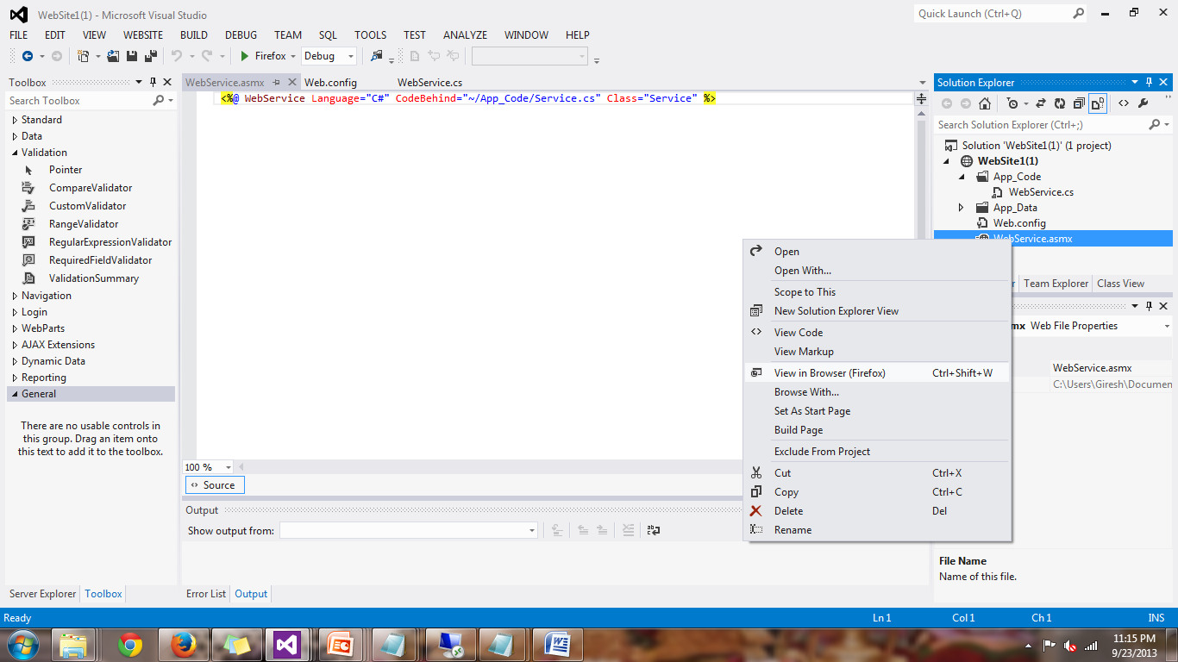Step4. The webservice is called in the browser by Webservice.asmx

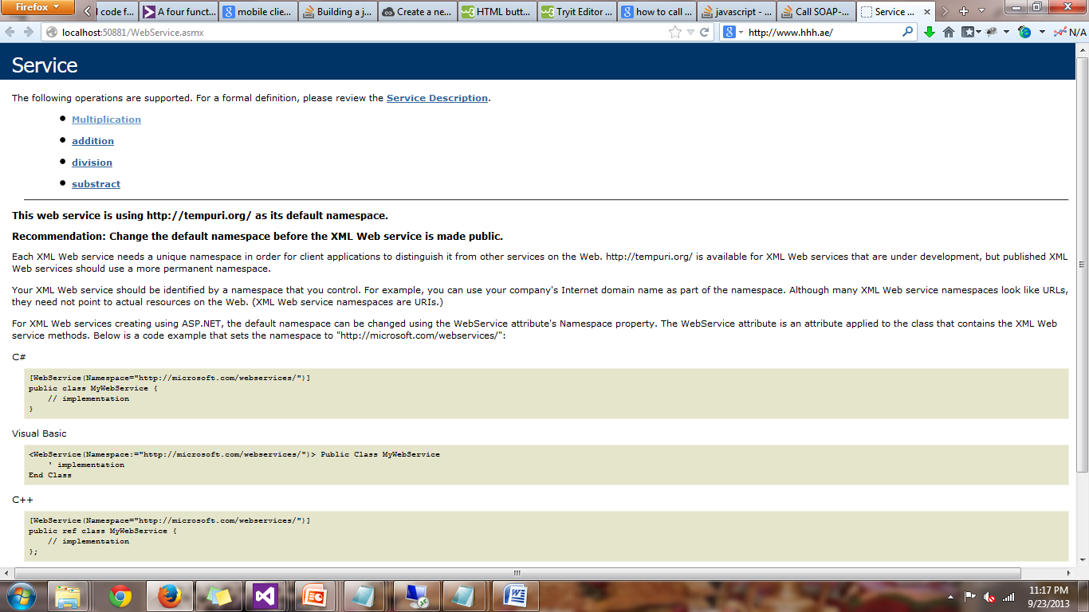Step5. The browser displays all the methods in the service

The local link is : <http://localhost:50881/WebService.asmx>

This local webservice is deployed in to the cloud

Step6.

Login in to the cloud and paste the website file from the local machine to the cloud C:\inetpub\wwwroot\aspnet_client

Step 7.

Now I opened the Internet Information Services IIS Manager and check for the file under the Websites

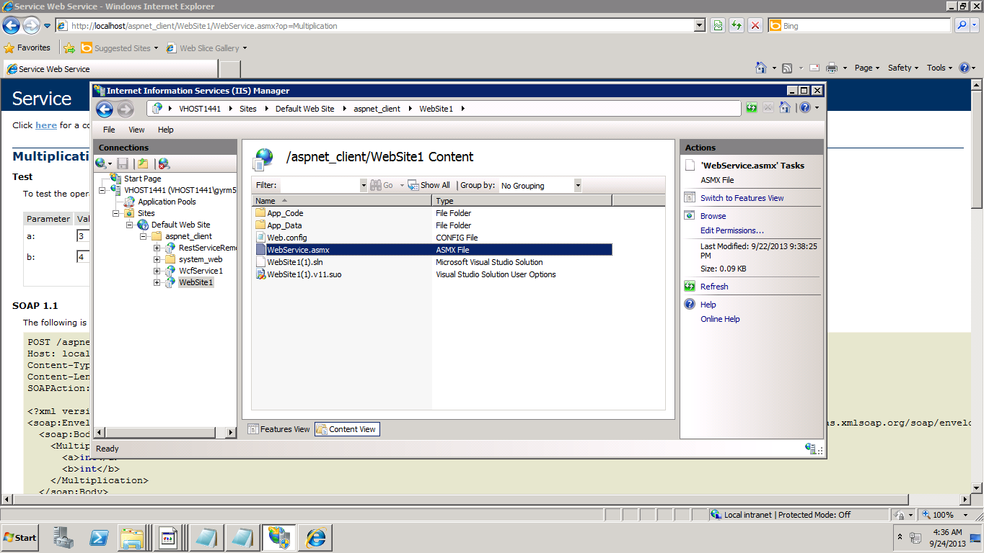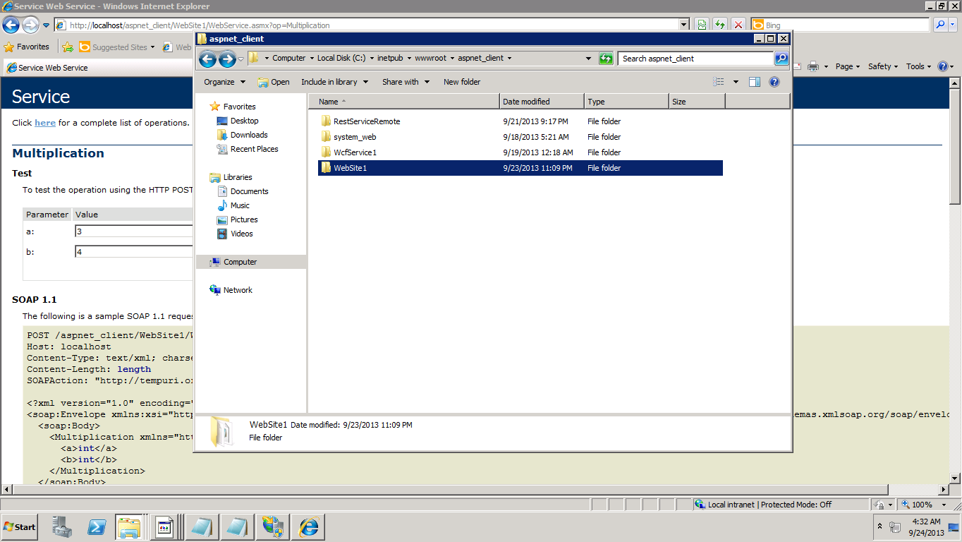

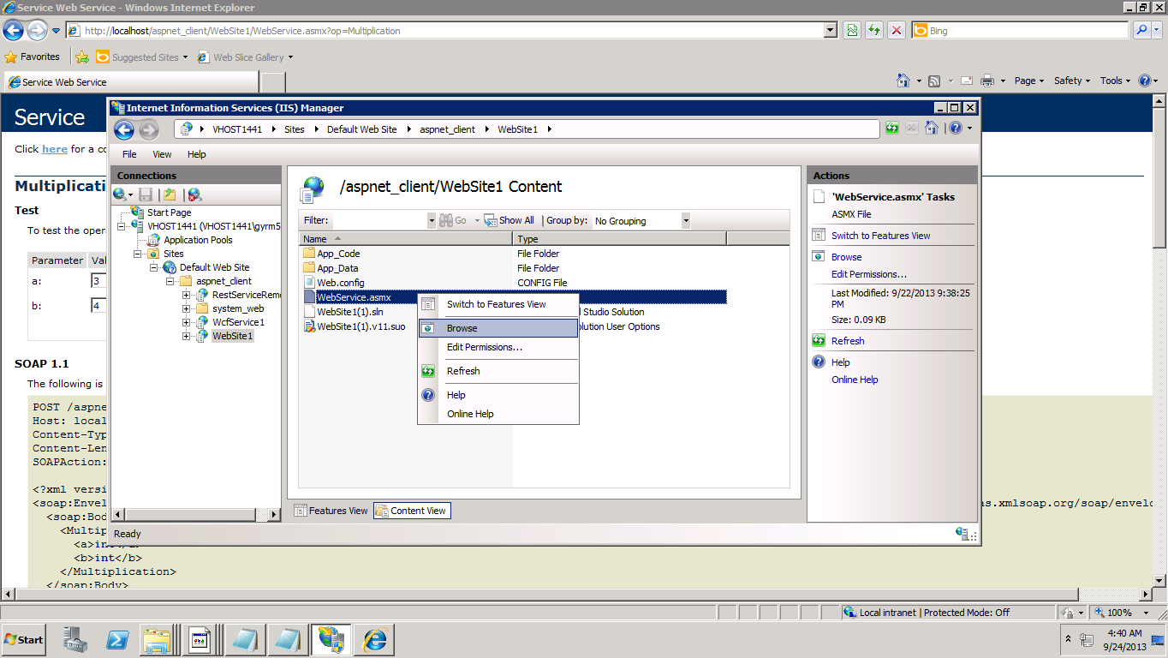After deploying the Webservice in the IIS of the cloud then right click the webservice .asmx and open in the browser

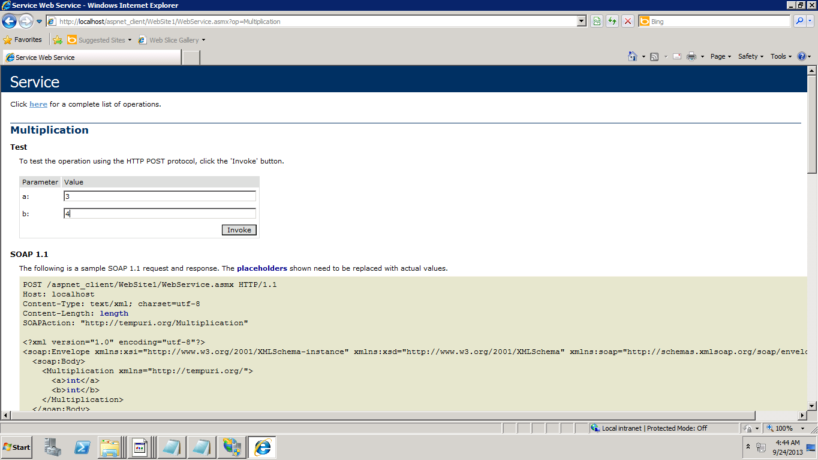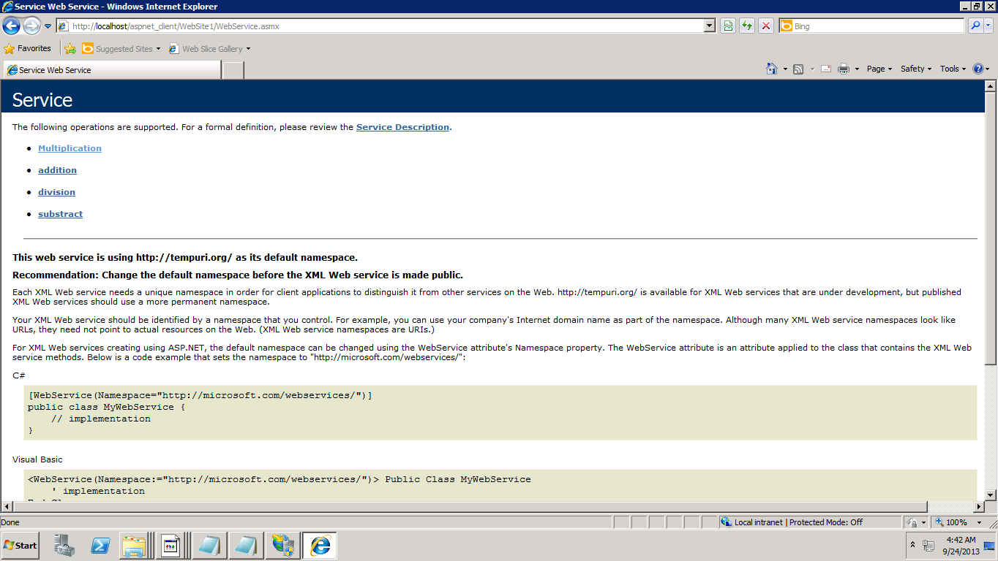No invoke the multiplication method to see the functionality

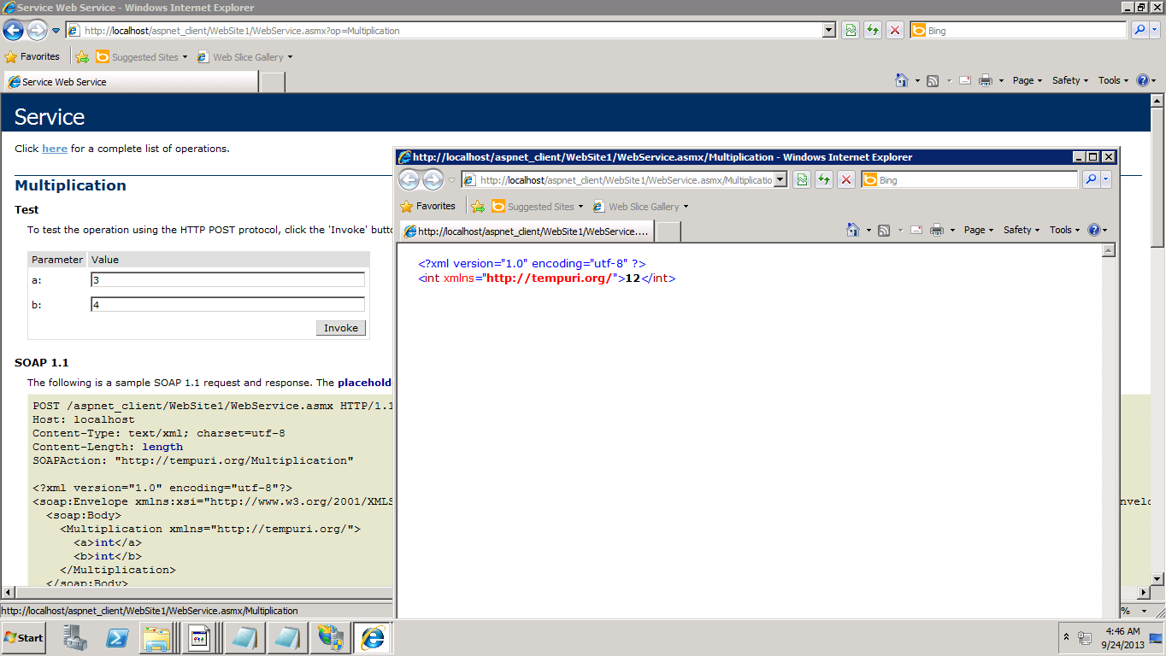when you invoke the method it return as value that is computed

My soap webservice remote :

http:// vhost1441.site1.compute.ihost.com/aspnet_client/WebSite1/WebService.asmx

Creating the Web Client Application

Step 1. I created a new Website in the visual studio and then add the new item as the webform

Step add the service reference to the webform by the cloud deployed Saop service by the url :

http:// vhost1441.site1.compute.ihost.com/aspnet_client/WebSite1/WebService.asmx

Now create a form in the Default.aspx page by dragging and dropping in to the page after it written the C# Code in to the Default.aspx.cs file to call the SOAP Service

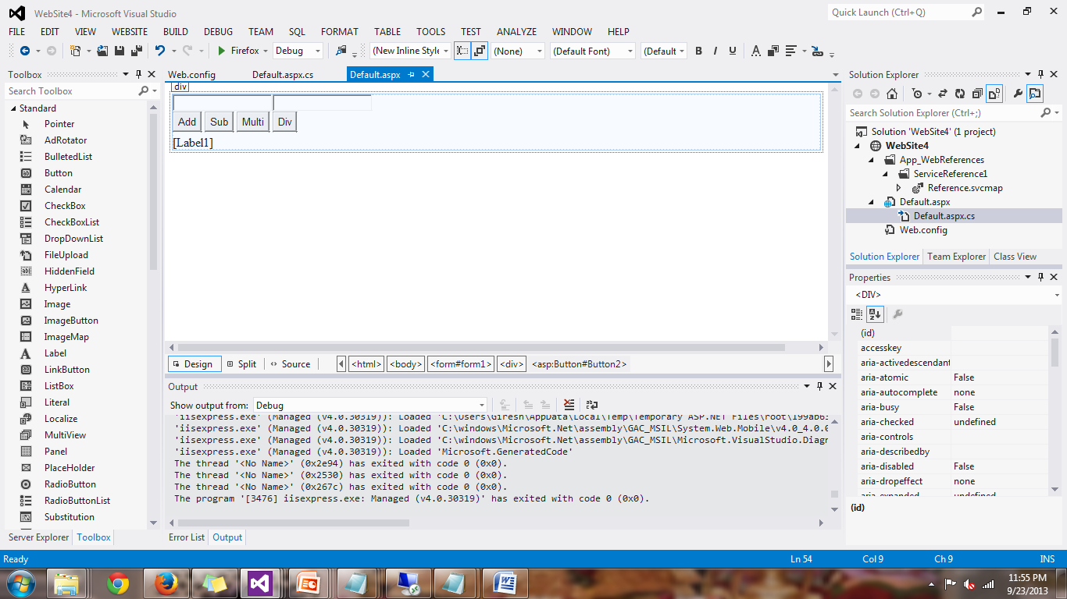Then run the client in the webbrowser

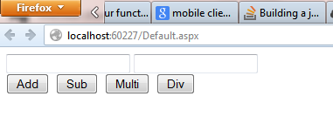

Rest Service

I created a REST webservice called WEBService 3 and then deployed in the IIS Manager

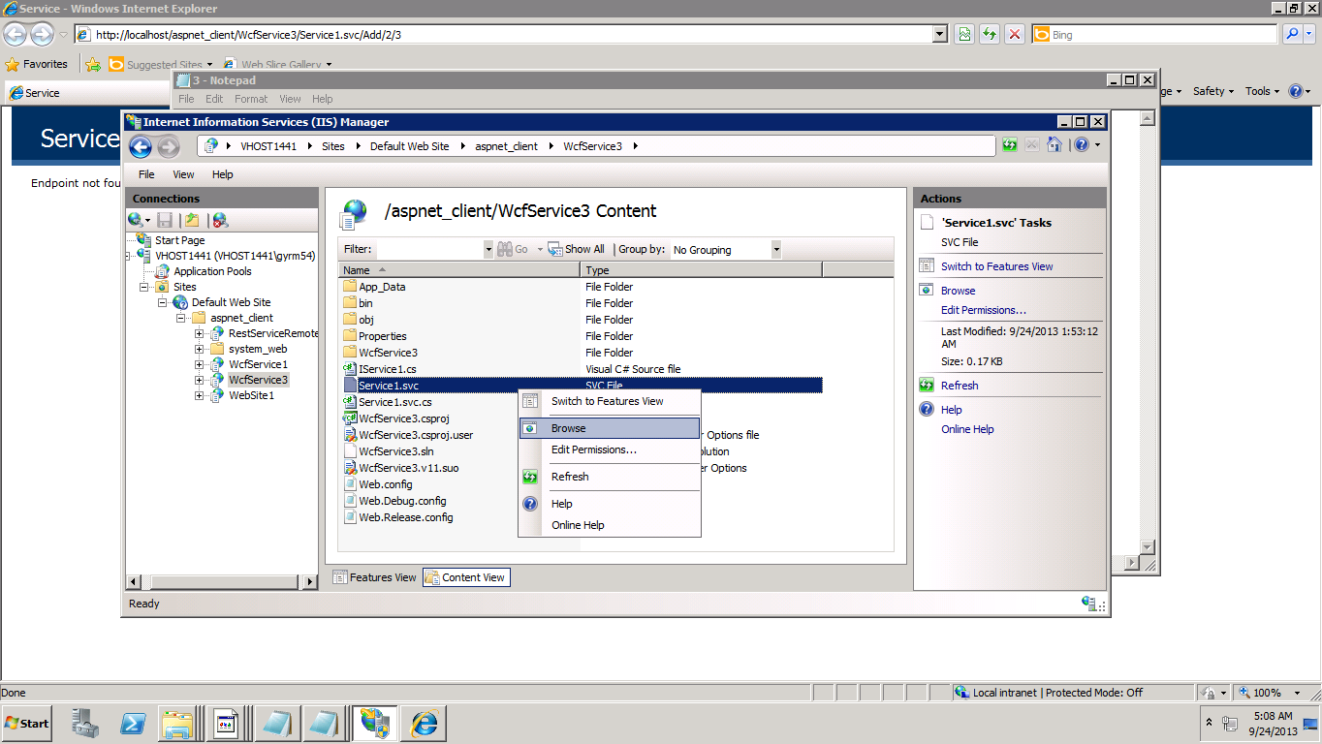

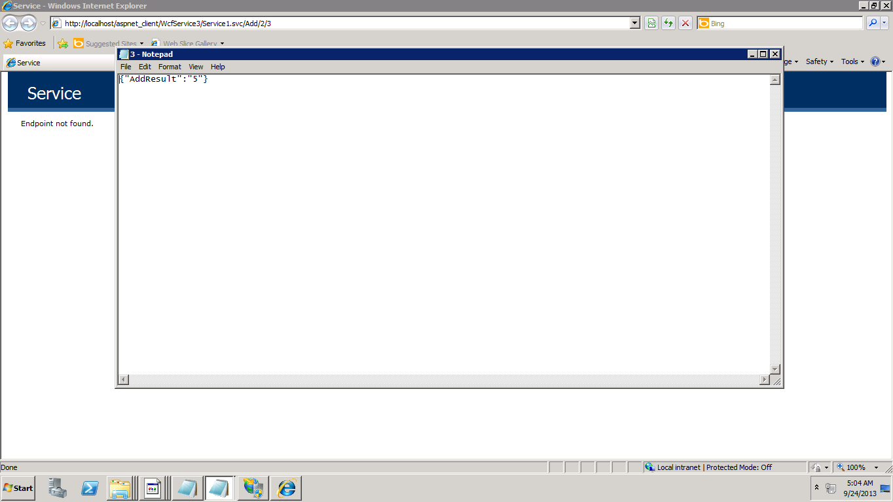

The my REST Service Link

<http://vhost1441.site1.compute.ihost.com/aspnet_client/WcfService3/Service1.svc/>